An **iFrame** (Inline Frame) is HTML document embedded inside the current HTML document on a website. iFrame HTML element is used to insert content from another source, such as an advertisement, into a Web page.

iFrame is defined by an <iframe></iframe> tag in HTML. With this tag you can identify an iFrame while inspecting the HTML tree. One can identify **iframes using firebug > HTML OR record in selenium IDE**

**Program is in eclipse

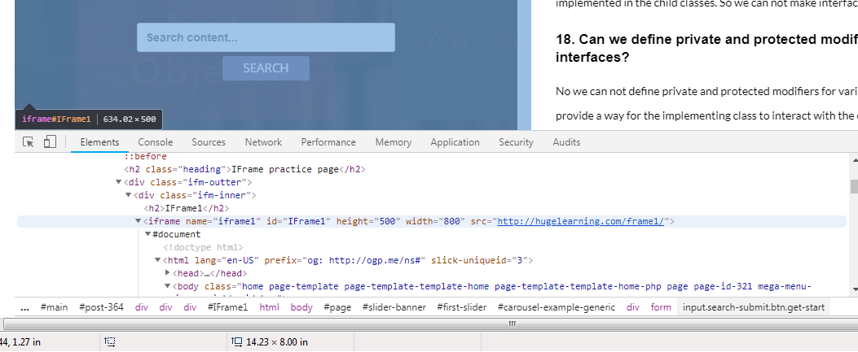

dr.manage().timeouts().implicitlyWait(15, TimeUnit.***SECONDS***);

Thread.*sleep*(2000);

dr.switchTo().frame("IF1");

To move back to the parent frame, you can either use switchTo().parentFrame() or if you want to get back to the main (or most parent) frame, you can use switchTo().defaultContent();

driver.switchTo().parentFrame();

driver.switchTo().defaultContent();